Tools for Inventory (TFI)

Product Definition Document

Document summary

This document provides details for Tools for Inventory (TFI) application

Document Status

Draft

Author(s)

Anton Solonchenko

EchoStar™

Table of Contents

Table of Contents 2

1. Revision history 4

1.1. Approval 4

2. Abbreviations, acronyms and definitions 4

3. References 5

4. Scope 6

5. Overview 7

6. Responsibilities 8

7. Requirements 9

7.1. Supporting platforms 9

7.1.1. Web-browser Support 9

7.1.1.1. Web-application: 9

7.1.1.2. Mobile application: 9

7.1.2. Mobile application 9

7.1.2.1. iOS application 9

7.1.2.2. Android Application 9

7.2. User roles 10

7.3. Logic of TFI 10

7.3.1. Web part of TFI 10

7.3.1.1. Home page for admin user 12

7.3.1.1.1. Hardware 13

7.3.1.1.2. Books 14

7.3.1.1.3. Administration 14

7.3.1.1.4. Add new item 15

7.3.1.2. Home page for user 15

7.3.1.2.1. Hardware 16

7.3.1.2.2. Books 16

7.3.1.2.3. Add new item 16

7.3.2. Mobile part of TFI 16

7.3.2.1. Mobile user interface 17

7.3.2.1.1. Mobile devices and screens 18

7.4. Fields 18

7.4.1. Hardware 18

7.4.2. Books 18

7.5. Changing inventory status 19

7.6. Reporting 19

7.7. Notification 19

7.8. Working with QR and Bar codes 20

Appendix 21

Appendix A. Android UI Mockup 21

Logging screen and Start Screen 21

Scan Screen and Search Result Screens 22

Search Screen 23

Settings Screen 24

Update item screen 25

# Revision history

|  |  |  |  |
| --- | --- | --- | --- |
| Revision | Date | Contributor | Comment |
| 00.00.01 | 10/18/2016 | Anton Solonchenko | Initial draft |
| 00.00.02 | 10/21/2016 | Anton Solonchenko |  |
| 00.00.03 | 10/25/2016 | Anton Solonchenko | Check comments |
| 00.00.04 | 10/28/2016 | Anton Solonchenko | Check comments and added mockups |
| 00.00.05 | 10/31/2016 | Stas Savinov | Mockup for Mobile devices |
| 00.00.06 | 11/02/2016 | Anton Solonchenko | Check comments |
| 00.00.07 | 11/03/2016 | Anton Solonchenko | Check Taras comments |

## Approval

|  |  |  |  |
| --- | --- | --- | --- |
| Revision | Date | Reviewer | Comment |
|  |  |  |  |
|  |  |  |  |
|  |  |  |  |
|  |  |  |  |

# Abbreviations, acronyms and definitions

|  |  |
| --- | --- |
| Abbreviation | Description |
| TFI | Tools for Inventory |
| PC | Personal Computer |
| iOS | Mobile operating system created and developed by Apple Inc. |
| API | Application programming interface |
| Open GL | Open Graphics Library |

# References

* Old inventory process - <https://epoint-europe.echostar.com/portals/toolsandequipment/Wiki/Kharkiv%20inventory%20process.aspx>

# Scope

This document is a product definition of Tools for Inventory (TFI) for Kharkiv Echostar office that will replaced current inventory application.

The main purpose of inventory process is monitoring state of engineering inventory. Easy find location of inventory. Track history of using inventory to effective choice for new equipment.

Purpose of this document – provide main cases for inventory system by describing main scenarios and global tasks. Also, give detail descriptions on current system with all main functionalities.

This document is meant for managers, developers and testers, who will create, review or maintain the TFI application.

*This is a live document and shall be updated as and when more clarity emerges on open items.*

# Overview

The TFI should provide the following opportunities to user:

* add new inventory to inventory base;
* reassign inventory to other user or location;
* add different types of equipment to the base;
* set permission levels;
* support different set of filters;
* work with QR/Bar codes;
* generate reports;
* e-mail notification about changes in equipment state;
* cataloging all Kharkov equipment;
* supporting different platforms (Windows, Linux, Android and iOS);
* supporting different web-browsers (Google Chrome, Firefox Mozilla).

# Responsibilities

* **Admin** – person, who have administrative right in system.
* **Inventory responsible person (project inventory manager)** – person, who monitoring of execution inventory process, make revision inventory and manage inventory process into his own project group. Inventory manager assignee PL as Inventory Responsible Person (IRP) by default. Could be reassigned on team member by special request from the side of Project Lead.
* **User** – person from Kharkiv office.

# Requirements

This chapter will define main requirement for TFI of Echostar Kharkiv site. Main features and options should be gathered here. More detail information will be placed in a separate architecture design documents with links in this document.

## Supporting platforms

The TFI application should work with web-browser and should have mobile client application (for iOS and Android). Mobile client for TFI application will have reduced functional compared to web-application.

### Web-browser Support

#### Web-application:

|  |  |  |
| --- | --- | --- |
| **Browser** | **Version** | **Phase** |
| Firefox Mozilla | Previous, current and future (beta) | Phase 1 |
| Google Chrome | Previous, current and future (beta) | Phase 1 |
| Internet Explorer | Previous, current and future (beta) | Phase 2 (if it will be needed) |

#### Mobile application:

Mobile application should be as separate application which running onto mobile devices. Also user should be able to open Tools for inventory using mobile browser, but will not be full supported.

### Mobile application

#### iOS application

iOS application of TFI application should be correspond to the next requirements (mobile application will be focused on devices that we have in Kharkiv office):

* support iPhone 5S and higher with iOS 9 and higher;
* support iPad Mini 3 and higher with iOS 9 and higher;
* support iPad Air 2 and higher with iOS 9 and higher.

#### Android Application

Android application of TFI application should be correspond to the next requirements:

* minimum API version 19;
* support **TBD** screen;
* minimum Open GL version – **TBD**.

## User roles

For TFI applications, we need to have the next user roles:

* Administrator will be able to:
  + add/delete/modify all fields/information;
  + create new categories, types etc.;
  + can provide admin rights to other user.
* User will be able to:
  + add new item;
  + user should send request to Admin for new model and manufacture (in case they are absent in the list);
  + user could re-assign item to the other user or change item’s location (Admin should get notification);
  + user should send request to Admin for move item to the storage.
* Tester - the same rules as administrator (this role need only for testing TFI application).

## Logic of TFI

In this part of document described main logic for web and mobile parts of TFI application.

### Web part of TFI

For access to TFI we should use the next logic:

1. User should open web page and go to web-address of TFI home page.

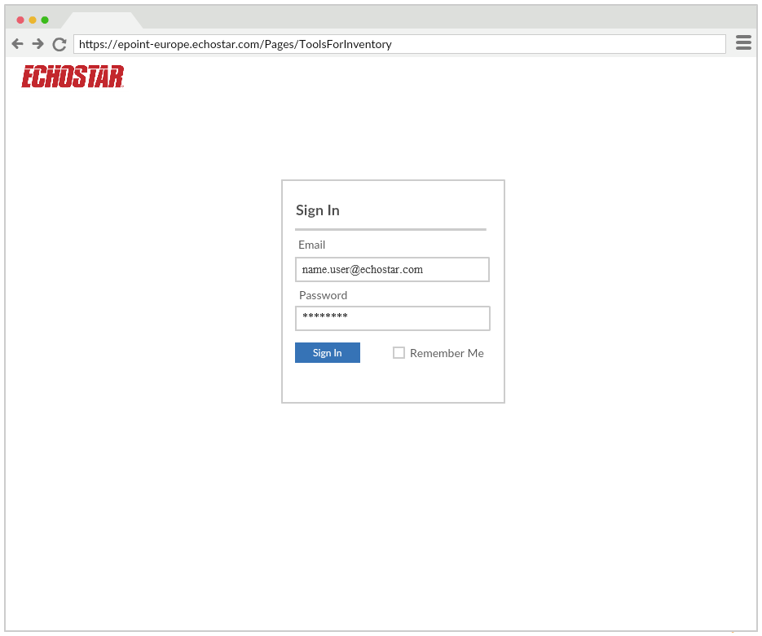

Pic. Sign in page mockup

1. User should insert his NT credential to access.
2. Check credentials – does this user exist or no.
3. If user don’t exist or some mistakes in login/password – user should put correct credentials (User will lock his account after 3 incorrect attempts. This is current NT domain rule.).
4. If credentials correct – check what type of account have this user (admin or user)
5. Open home page for this user.



### Home page for admin user

Home page for admin have the next sections:

* Hardware
* Books
* Administration
* Add new item

Also at home page user can see all items that assigned to him.

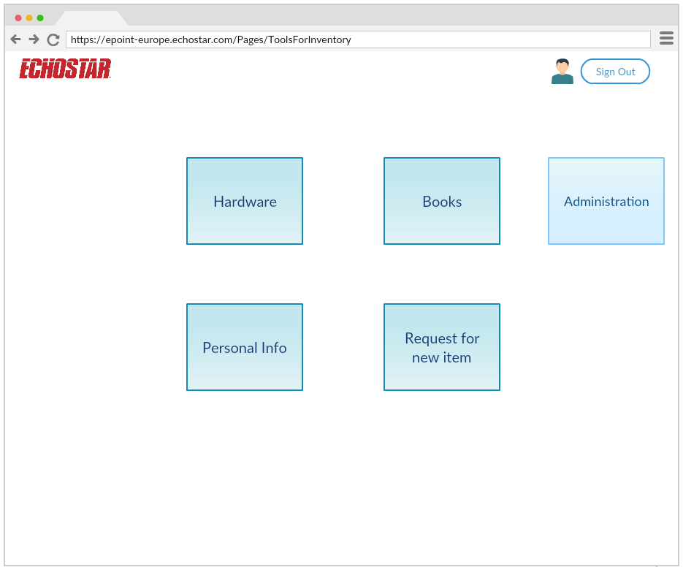

Pic. Admin home page mockup

#### Hardware

In this section user see all hardware items, which added to system, and he can add new hardware item to base. For these items user can see only that fields which is applicable for current equipment type.

Also user can use filters for its convenience.

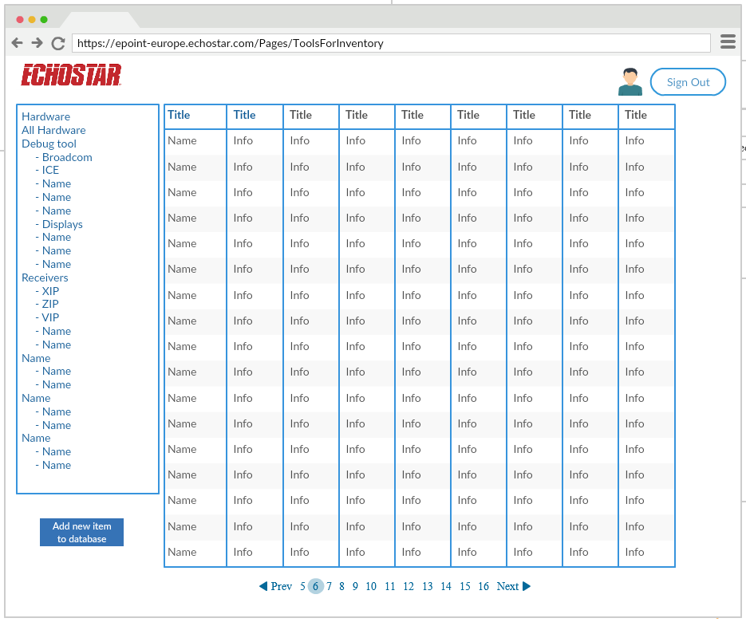

Pic. Hardware page mockup

#### Books

In this section user can see all books, which added to system, and he can add new books item to base.

Also user can use filters for its convenience.

#### Administration

In this page administrator can do the next:

* Managing users accounts;
* Adding/deleting new category, types of items etc…;
* Set up rules for notifications/reporting
* TBD…

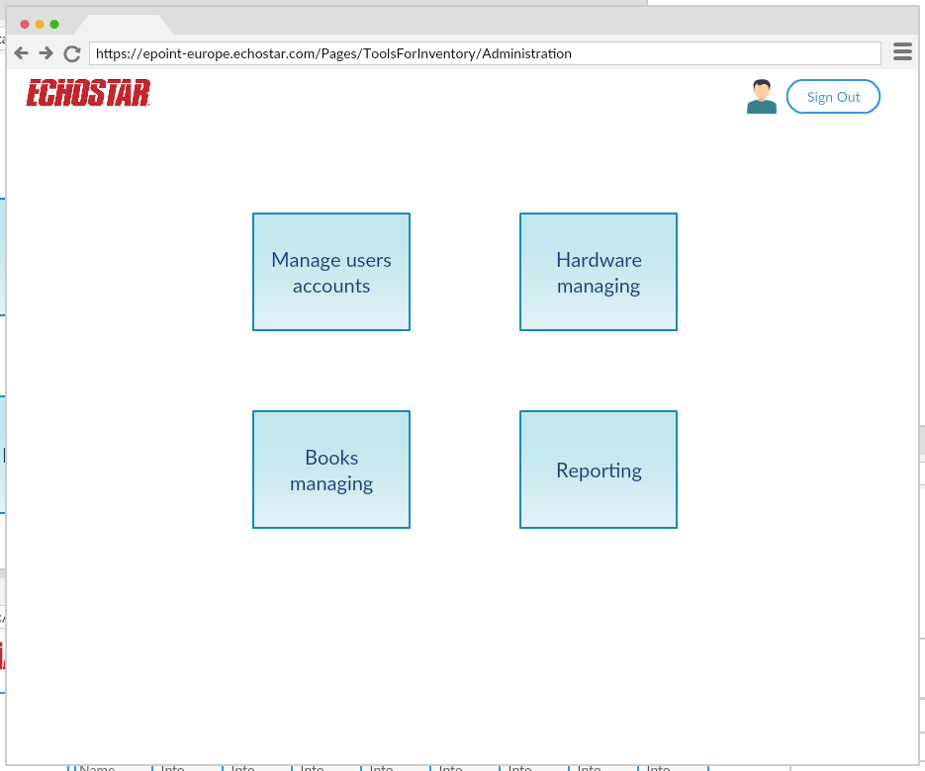

Pic. Administration page mockup

#### Add new item

In this page user can add new item to base (hardware, books etc.)

### Home page for user

Home page for ordinary user is containing the next section:

* Hardware
* Books
* Personal info
* Add new item

Also at home page user can see all items that assigned to him.

#### Hardware

In this section user can see all hardware items, which added to system, and he can add new hardware item to database.

Also user can use filters for its convenience.

#### Books

In this section user can see all books, which added to system, and he can add new books item to base.

Also user can use filters for its convenience.

#### Add new item

In this page user can add new item to base (hardware, books etc.).

### Mobile part of TFI

Mobile version should support the next:

* scanning QR/Bar codes;
* checking items properties;
* user should have ability to adding new item to database;
* mobile version should have login page and opening personal page for user;
* mobile version should be able to take photos and add their to database.

#### Mobile user interface

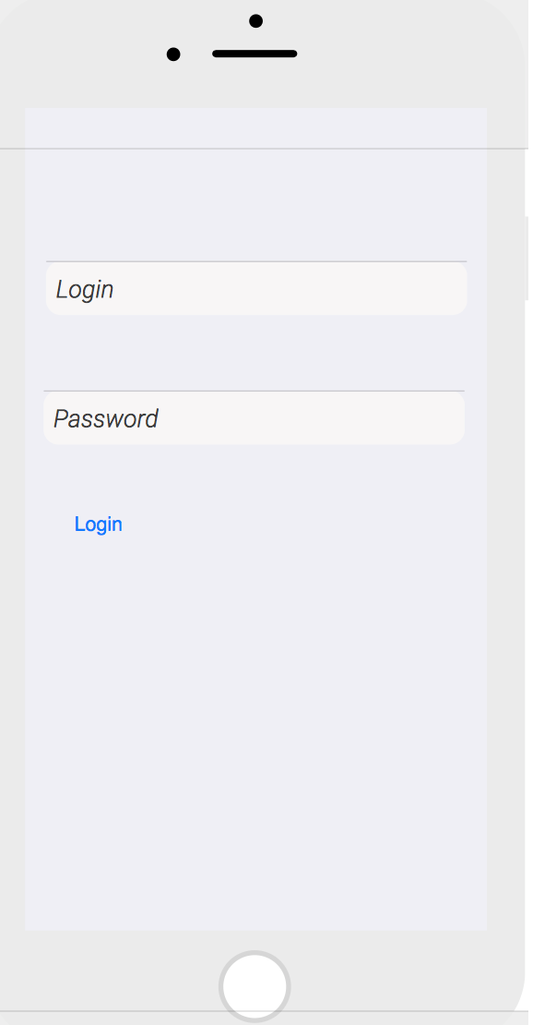 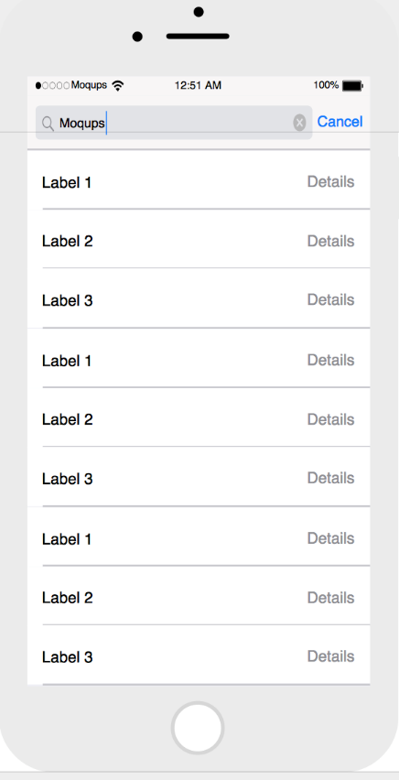 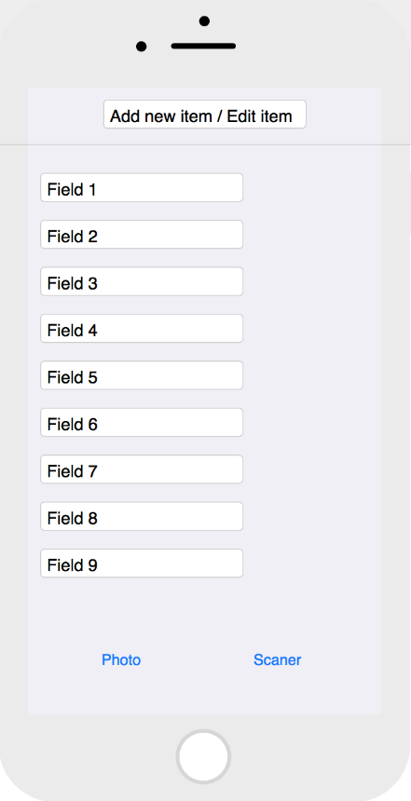

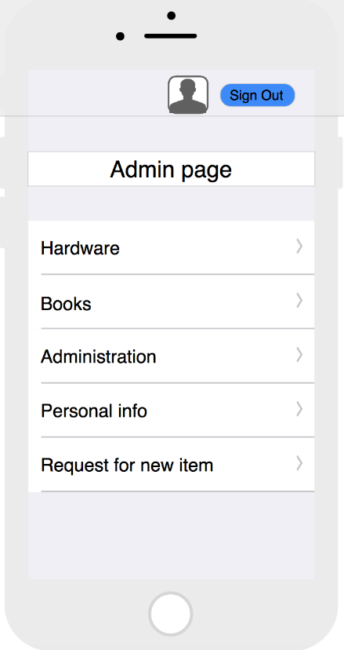 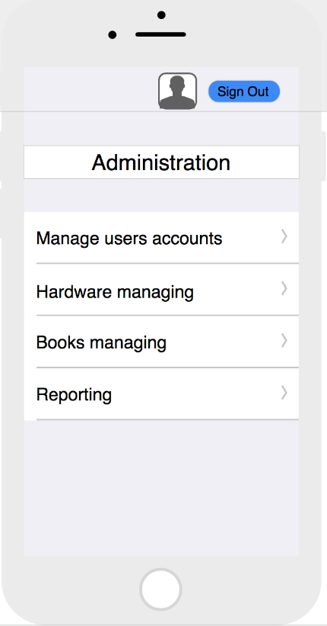 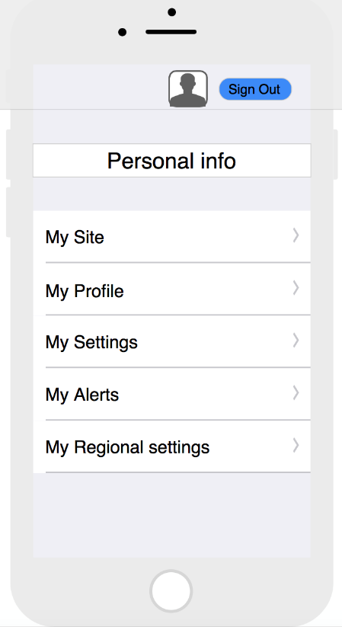

##### Mobile devices and screens

* iPhone 6, 6s, 7 (4.7 in (120 mm), 4.1 in (100 mm) by 2.3 in (58 mm));
* iPhone 6+, 6s+, 7+ (5.5 in (140 mm), 4.8 in (120 mm) by 2.7 in (69 mm));
* iPhone 5, 5s, se (4 in (100 mm), 3.5 in (89 mm) by 1.9 in (48 mm));
* iPad mini (7.9 in (200 mm));
* iPad pro (12.9 in (330 mm));

## Fields

### Hardware

All of these fields provide filtering functionality.

Item card has fifty teen (15) field with possibility to change by administrator them in case user has correct credentials for this operation:

|  |  |
| --- | --- |
| # | Field name |
| 1 | Title |
| 2 | Manufacturer |
| 3 | Model |
| 4 | Serial Number |
| 5 | Equipment Status |
| 6 | Assigned to |
| 7 | Return date |
| 8 | Office |
| 9 | Equipment Location |
| 10 | Next revision |
| 11 | Guarantee Expiration |
| 12 | Comments |
| 13 | Photo/Picture |
| 14 | Bar/QR code |
| 15 | Type |

### Books

All of these fields provide filtering functionality.

Item card has seventeen (17) field with possibility to change by administrator them in case user has correct credentials for this operation:

|  |  |
| --- | --- |
| # | Field name |
| 1 | Title |
| 2 | Author |
| 3 | Keywords |
| 4 | ISBN |
| 5 | Book Publisher |
| 6 | Year |
| 7 | Language |
| 8 | Department tag |
| 9 | Assigned to |
| 10 | Location |
| 11 | Last revision |
| 12 | Cost in USD |
| 13 | Last revision |
| 14 | Next revision |
| 15 | Comments |
| 16 | Photo/Picture |
| 17 | Bar/QR code |

## Changing inventory status

This screen is for changing inventory status. Administrator can change all fields for item. For any status changes ordinary user should sent request to administrator.

## Reporting

System should generate and automatically sent weekly report to system administrator via email.

Report should support filtering (name, item etc…).

Rules for reporting:

* Adding new item;
* Changing status, location, assigner and other settings for items.

## Notification

System should support email notification system. For all users notifications enabled be default and user cannot disable it.

Notifications should send in the next cases:

* adding new item;
* changing location;
* changing status and ‘assign to’;
* user will get notification in case of new item is assigned or re-assigned to him;
* admin will get notification in case if any data is changed in item.

Notifications should be send to person who make changes and to person to whom is assigned this item.

## Working with QR and Bar codes

System should support work with bar and/or QR codes which located onto inventory (factory bar code and/or system generated bar/QR code). If inventory doesn’t have bar code it will be created from separate form where we can choose what bar code for item will be printed.

In case if serial number is available, bar code will not be generated.

# Appendix

## Appendix A. Android UI Mockup

### Logging screen and Start Screen

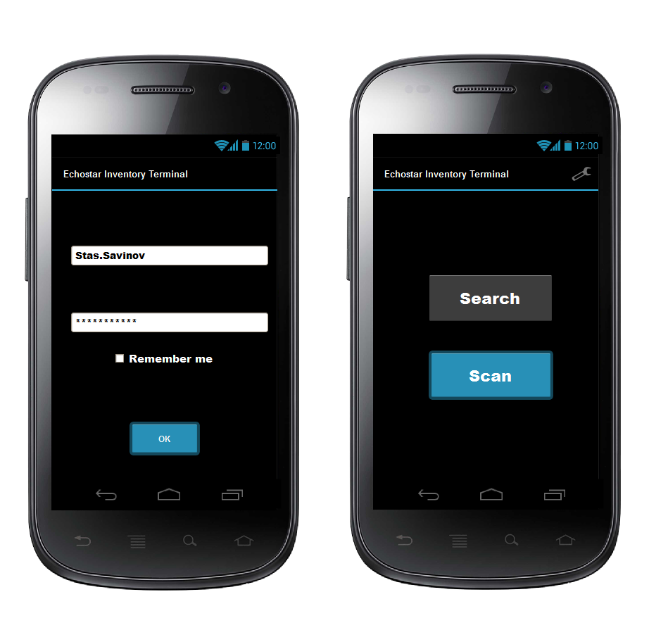

Logging screen should provide access to server with correct user access rights. Also should make easier to logging for same user.

Design pf the application is not a goal for this mockup, but rather understanding amount of screens to be considered.

### Scan Screen and Search Result Screens

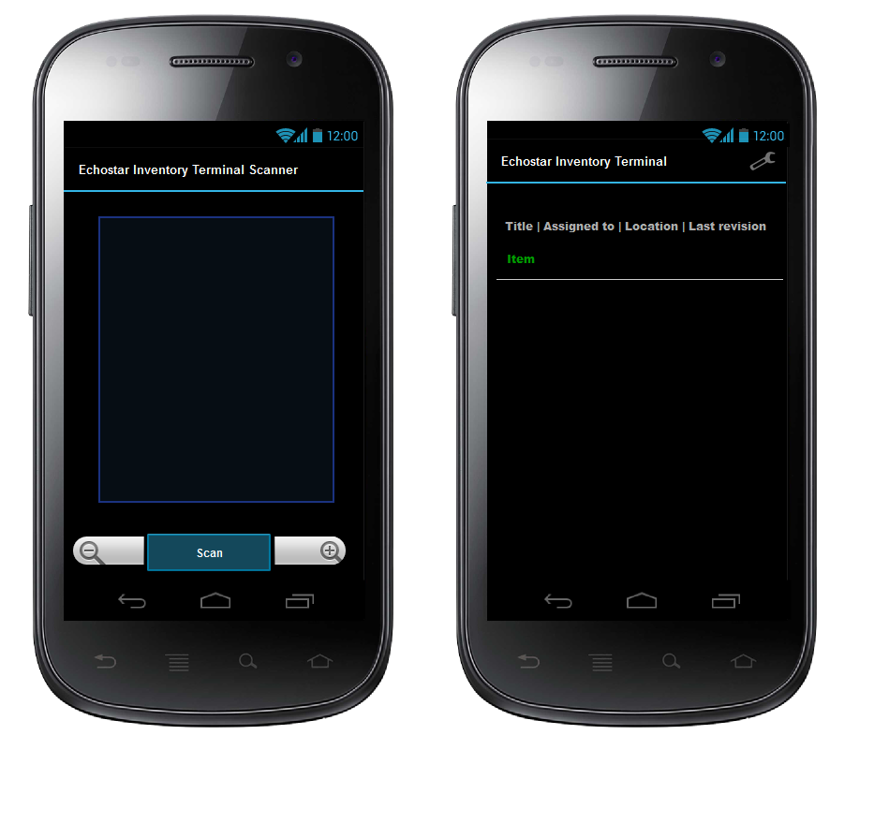

Scan screen will probably have Bar/QR code switcher in case no auto-detection feature will be possible. Also for convenience of Image scanning – flashlight activation should be available.

Result screen should show list of found items with selected fields. Fields can be adjust in settings screen. List will be scrollable. Tapping on each item in list should show full information of this item.

### Search Screen

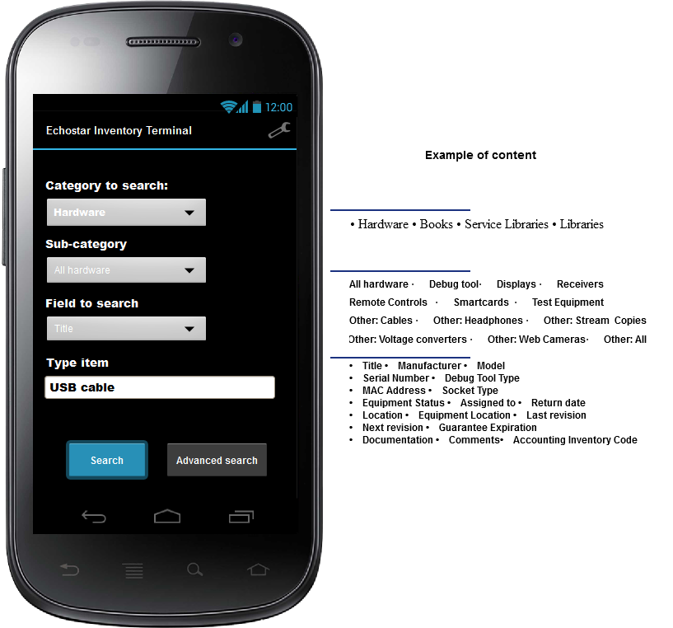

Elements for categories could be in combobox variant or just ordinal list with checkboxes and radio buttons. But the less UI elements will be present on screen, the faster application will be in general.

### Settings Screen

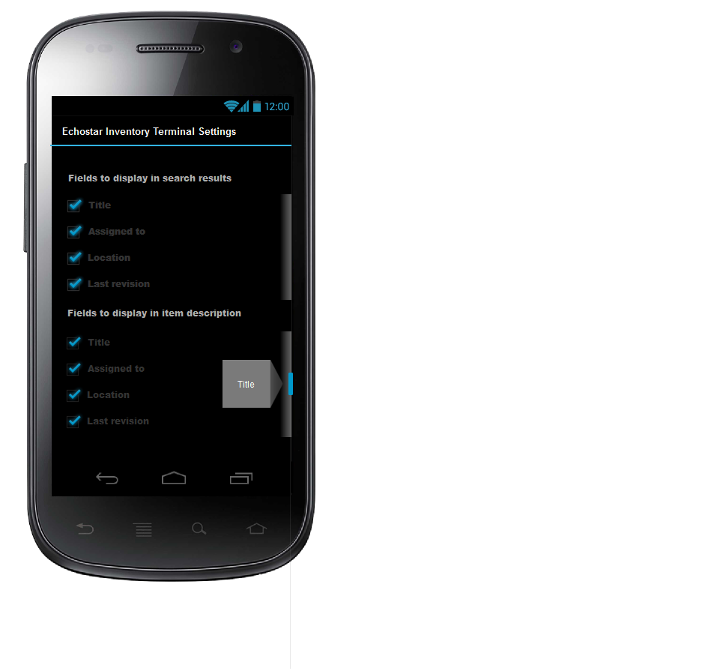

### Update item screen

